3rd module 3.1 & 3.2:

MERGE INTO bonuses b

USING EMPLOYEES2 e

ON (b.Employee_id = e.Employee_id)

WHEN MATCHED THEN

UPDATE SET b.Bonuses = e.Salary * .05;

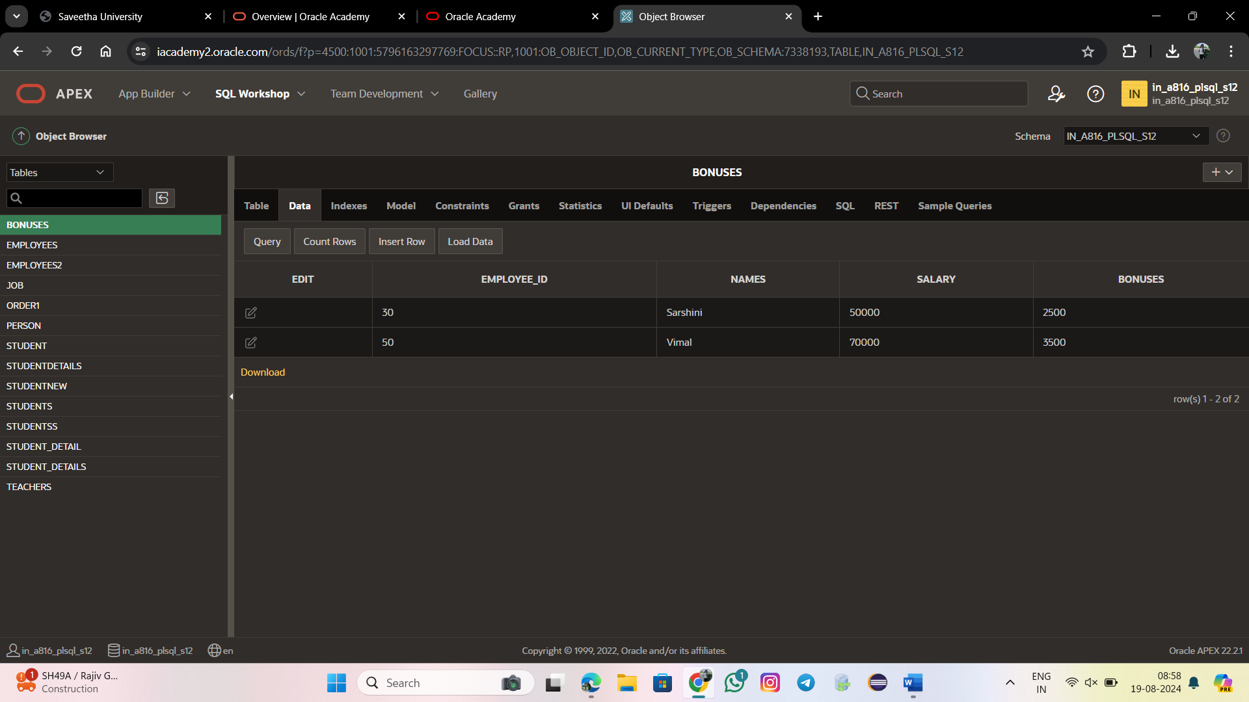

DECLARE

v_emp_lname Employees2.Names%TYPE;

BEGIN

SELECT Names

INTO v_emp_lname

FROM Employees2

WHERE Employee_id = 30;

DBMS_OUTPUT.PUT_LINE('Her last name is ' || v_emp_lname);

END;

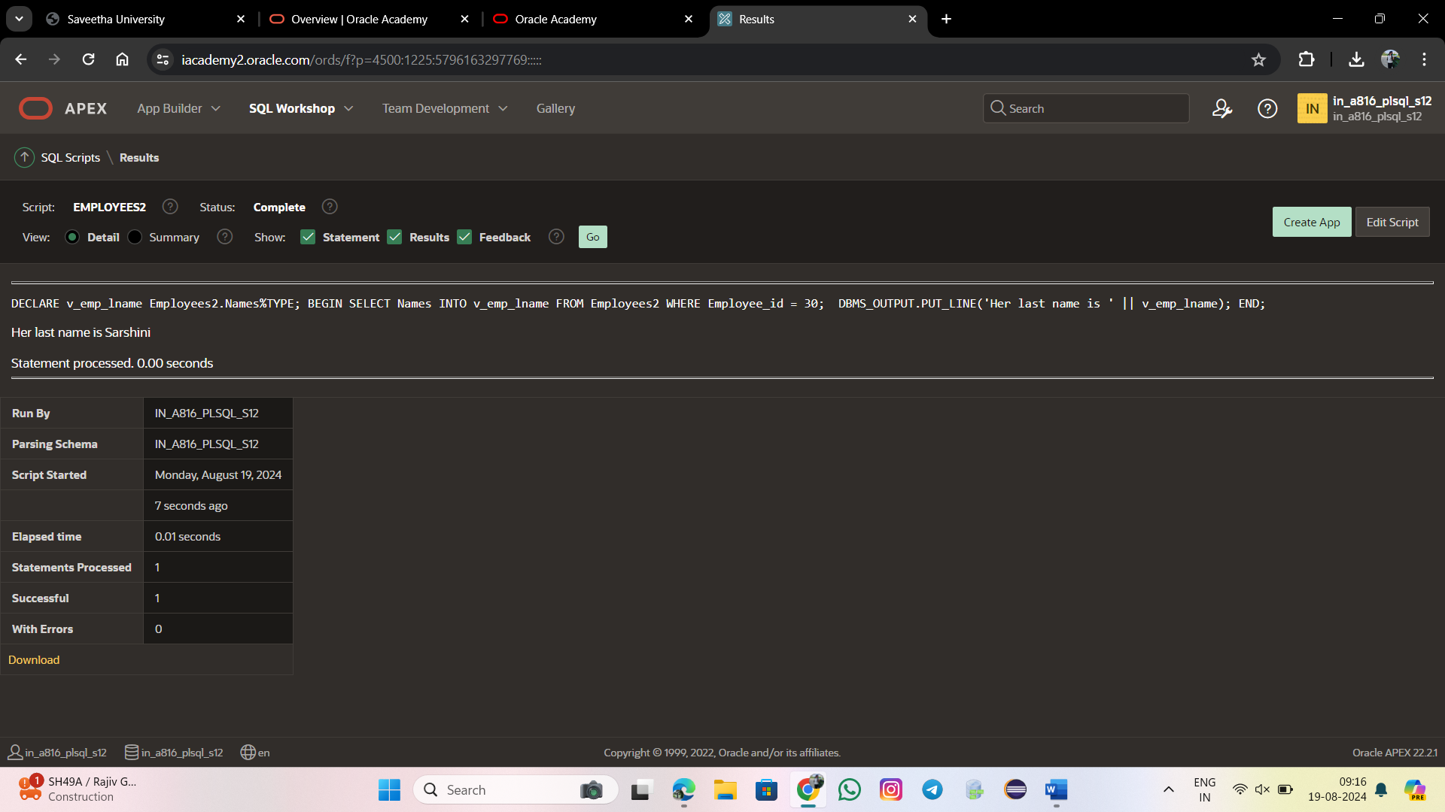

BEGIN

MERGE INTO EMPLOYEES2 c USING BONUSES e

ON (e.Employee_Id = c.Employee_Id)

WHEN MATCHED THEN

UPDATE SET

c. Names = e.Names,

c. Salary = e.Salary

WHEN NOT MATCHED THEN

INSERT VALUES(e.Employee_id, e.Names, e.Salary);

END;

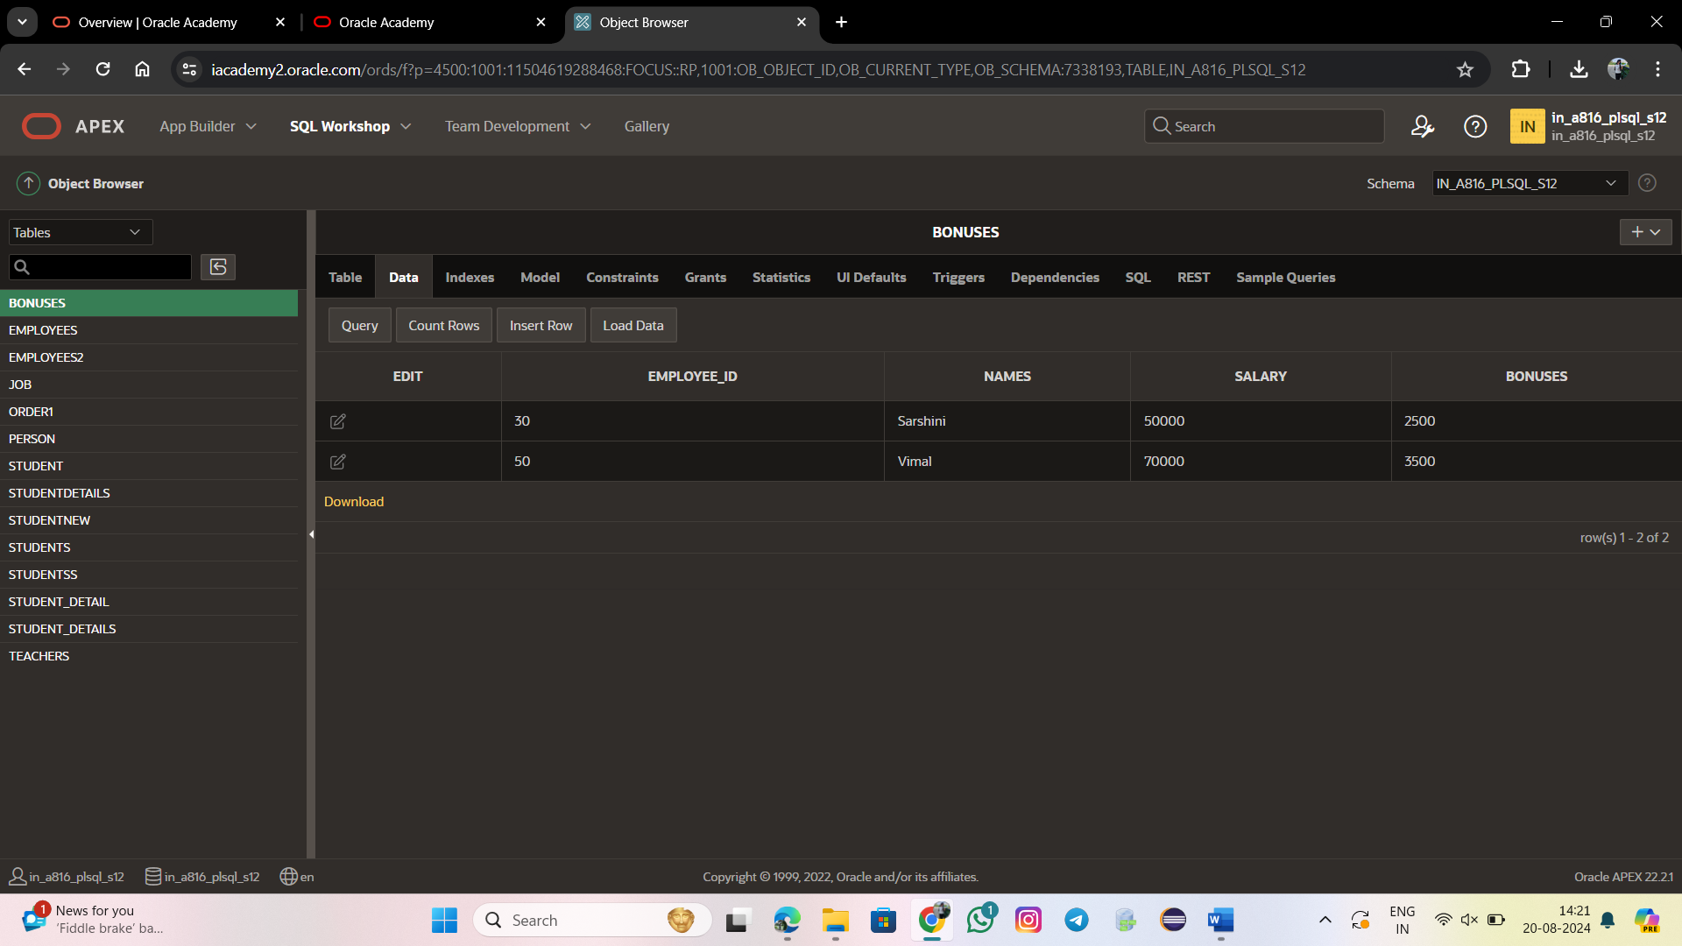

DECLARE

CURSOR c_emp_cursor IS

SELECT Employees_id, last_name FROM EMPLOYEES

WHERE department_id = 60;

v_empno employees.employees_id%TYPE;

v_lname employees.last_name%TYPE;

BEGIN

OPEN c_emp_cursor;

LOOP

FETCH c_emp_cursor INTO v_empno, v_lname;

EXIT WHEN c_emp_cursor%NOTFOUND;

DBMS_OUTPUT.PUT_LINE (v_empno || ' ' || v_lname);

END LOOP;

CLOSE c_emp_cursor;

END;

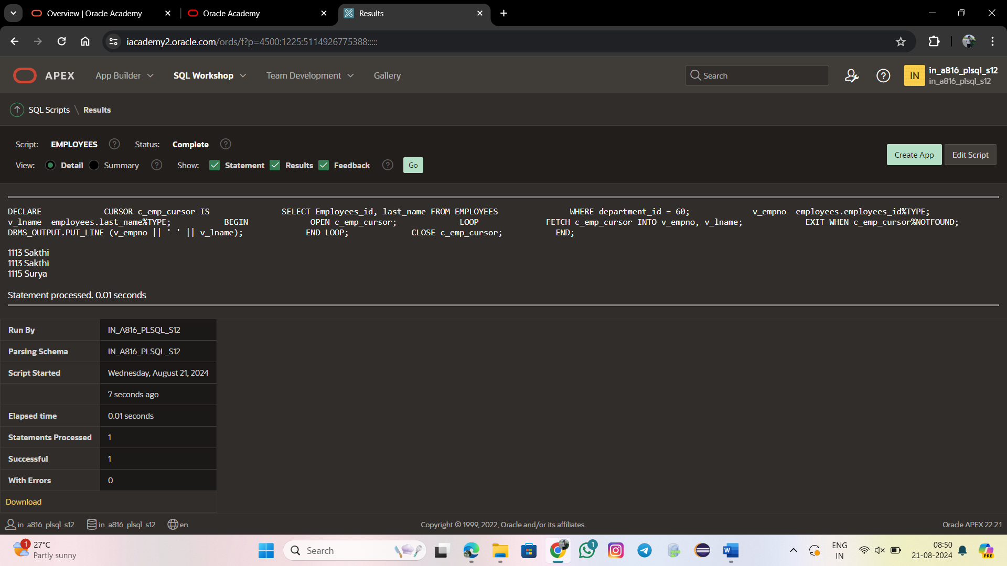

DECLARE

CURSOR c_emp_cursor IS

SELECT employees_id, last_name FROM EMPLOYEES

WHERE department_id = 60;

v_emp_record c_emp_cursor%ROWTYPE;

BEGIN

OPEN c_emp_cursor;

LOOP

FETCH c_emp_cursor INTO v_emp_record;

EXIT WHEN c_emp_cursor%NOTFOUND;

DBMS_OUTPUT.PUT_LINE (v_emp_record.employees_id || ' ' ||

v_emp_record.last_name);

END LOOP;

CLOSE c_emp_cursor;

END;

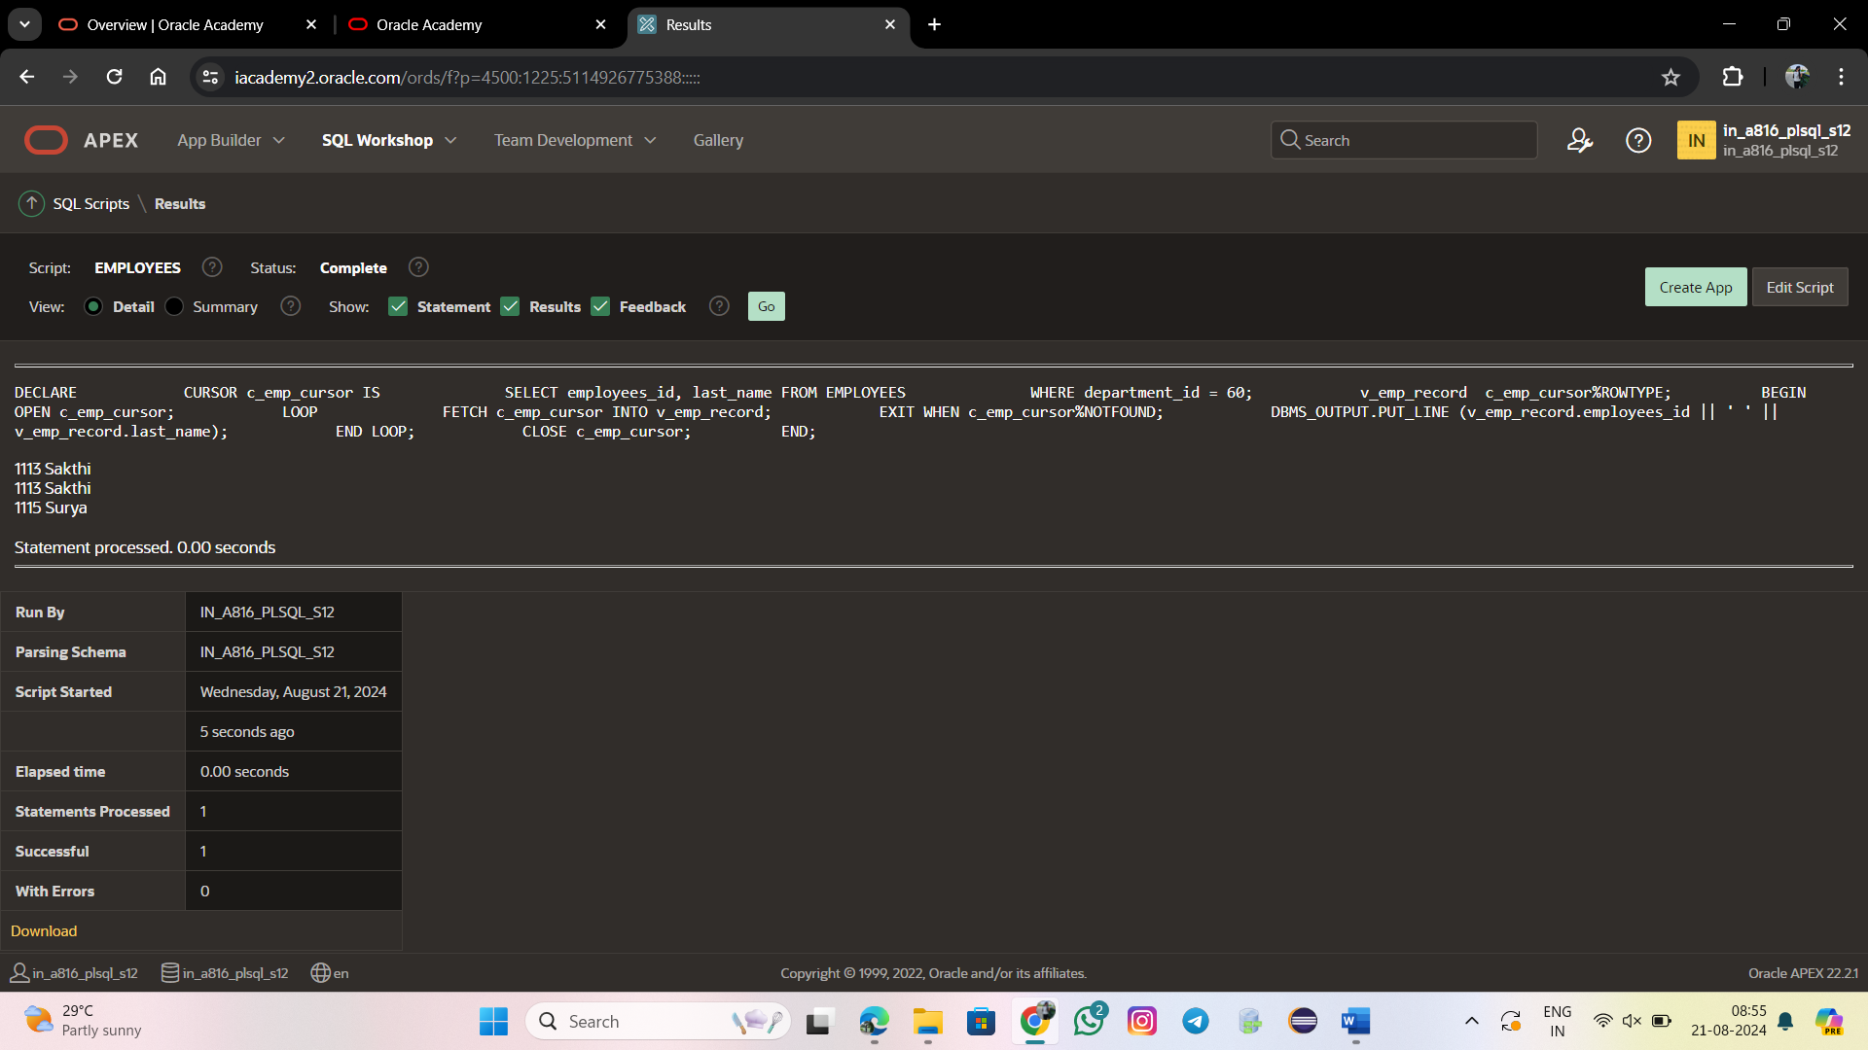

DECLARE

CURSOR c_emp_cursor IS

SELECT employees_id, last_name FROM EMPLOYEES

WHERE department_id = 60;

v_emp_record c_emp_cursor%ROWTYPE;

BEGIN

OPEN c_emp_cursor;

LOOP

FETCH c_emp_cursor INTO v_emp_record;

EXIT WHEN c_emp_cursor%ROWCOUNT > 4 OR c_emp_cursor%NOTFOUND;

DBMS_OUTPUT.PUT_LINE (v_emp_record.employees_id || ' ' ||

v_emp_record.last_name);

END LOOP;

CLOSE c_emp_cursor;

END;

